JENKINS-01
1.What is Jenkins?
Jenkins is an open-source automation server used to automate build, test, and deployment
processes.
Main uses
• Continuous Integration (CI)
• Continuous Delivery/Deployment (CD)
• Automate builds and tests
• Integrate Git/GitHub
• Run scripts and deployment jobs
1. Install Jenkins on EC2
Create EC2
• AMI: Amazon Linux 2023
• Instance type: t3.micro
• Allow inbound:
o SSH 22
o Custom TCP 8081
• Connect to EC2.
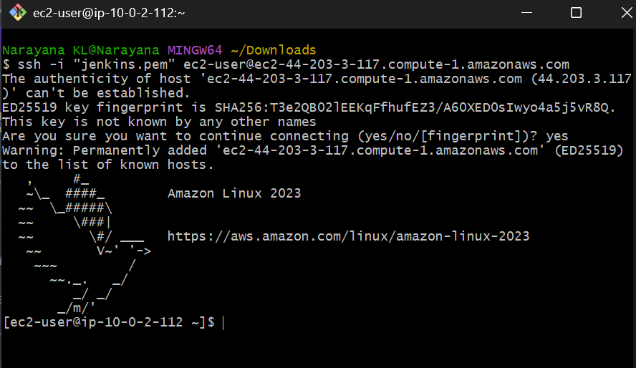
Install java
Command: sudo dnf update -y
Command: sudo dnf install java-17-amazon-corretto -y
Command: sudo wget -O /etc/yum.repos.d/jenkins.repo \
https://pkg.jenkins.io/redhat-stable/jenkins.repo
command: sudo rpm --import https://pkg.jenkins.io/redhat-stable/jenkins.io-2023.key
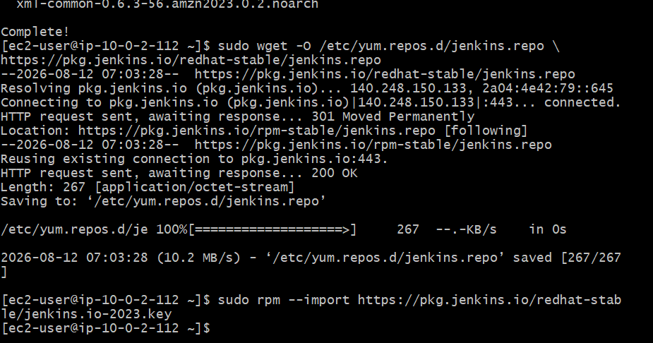
Install Jenkins
command: sudo dnf install jenkins -y
Start Jenkins:
sudo systemctl enable jenkins
sudo systemctl start jenkins
sudo systemctl status Jenkins
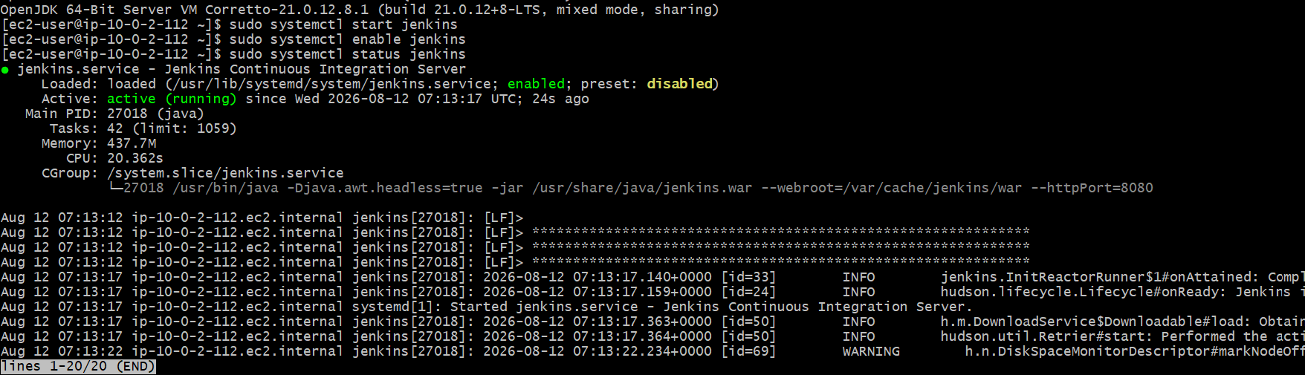
2. Run Jenkins on Port 8081
Jenkins Port 8081
Change Jenkins Port 8080 → 8081
By default Jenkins uses port 8080. Jenkins' official documentation recommends overriding JENKINS_PORT through the systemd service configuration.
Step 1: Create Jenkins systemd override
Run:
sudo systemctl edit jenkins
An editor opens.
Enter:
[Service]
Environment="JENKINS_PORT=8081"
Save and exit.
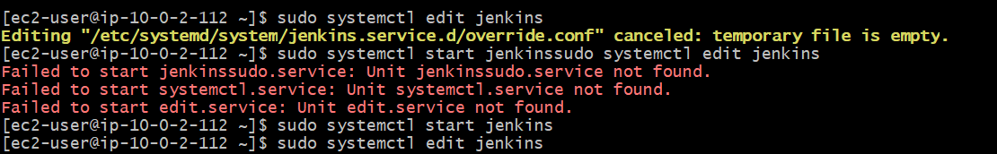
Reload systemd
sudo systemctl daemon-reload
Restart Jenkins:
sudo systemctl restart jenkins
Check:
sudo systemctl status Jenkins

Step 2: Verify Port
Run:
sudo ss -lntp | grep 8081
Expected:
LISTEN ... :8081 ...
You can also check:
sudo ss -lntp | grep java
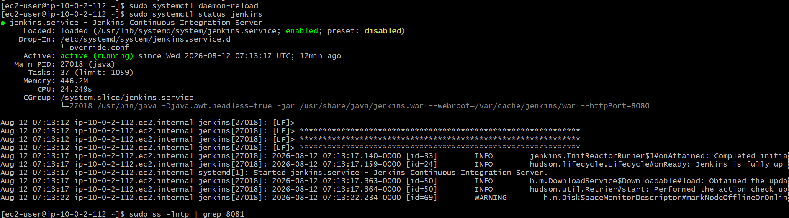
Step 3 — Configure AWS Security Group
This is very important.
Your EC2 instance must allow inbound TCP 8081.
Go to: AWS Console → EC2 → Instances → Your Jenkins EC2 → Security → Security Group Select:
Edit inbound rules Add:
Type | Protocol | Port | Source
Custom TCP | TCP | 8081 | Your IP
6. Open Jenkins
http://44.204.219.66:8081
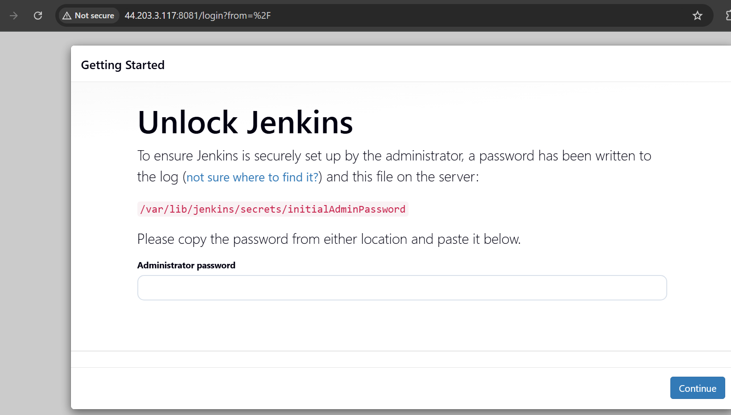
Get initial password:
sudo su
cd /var/lib/jenikins/
cd secrets/
ll
cat initialAdminPassword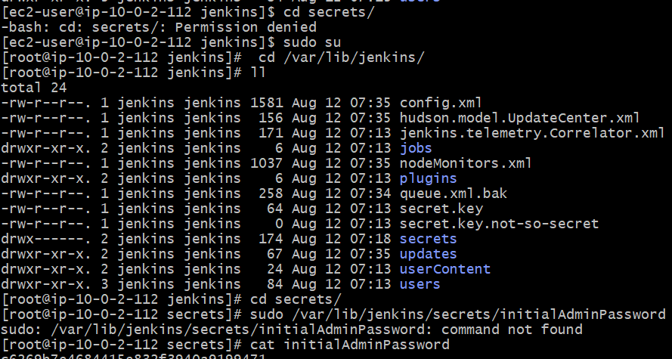
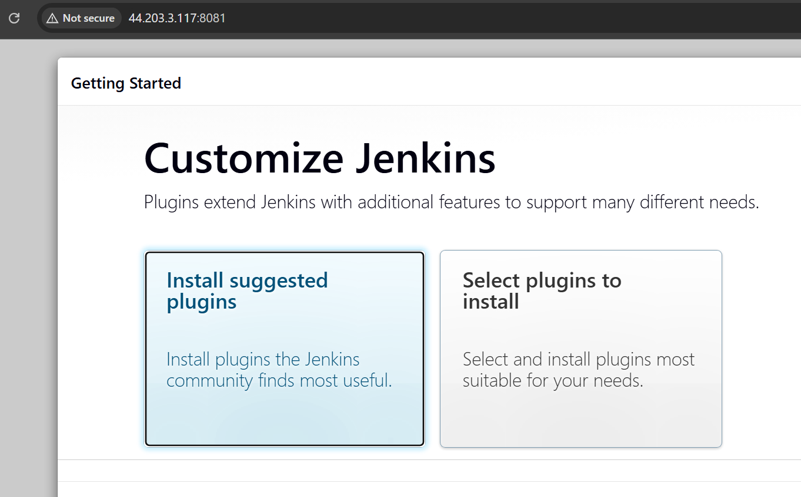
3. Secure Jenkins Server
Go to Manage Jenkins → Security.
2. Enable Jenkins' own user database.
3. Disable Allow users to sign up.
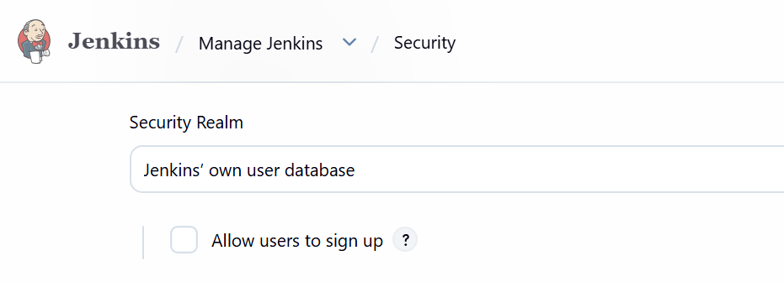

4. Select Matrix-based security or Role-Based Authorization.
5. Give only required permissions to users.
6. Keep Administrator access only for the admin account.
7. Save and apply. 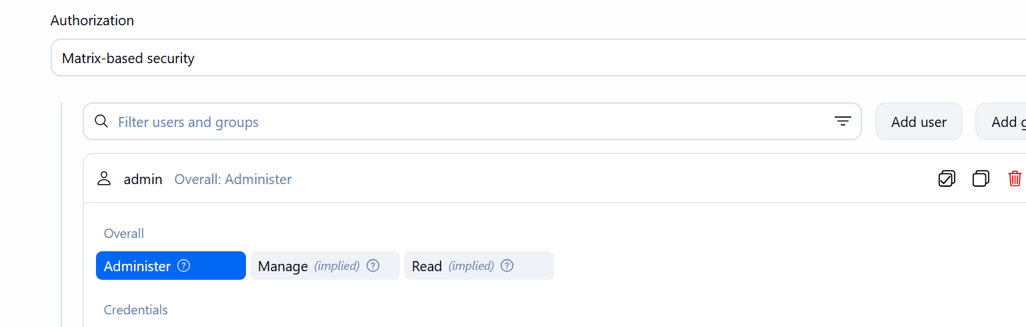
Create DevOps User
Go to: Manage Jenkins → Users
Click:
Create User
Enter:Username:DevOps, Password:<password>
Full name: DevOps User
Email:<email>
Click: Create User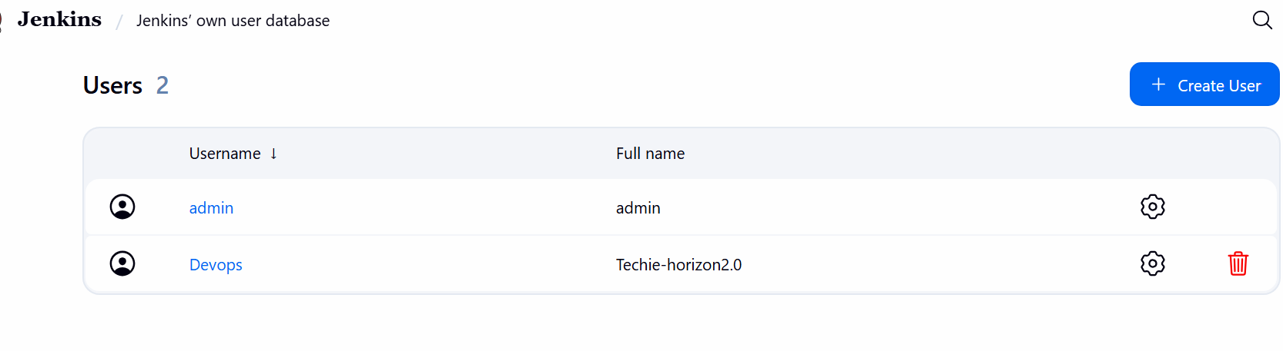

PART 7 — Create Testing User Again:
Manage Jenkins → Users → Create User
Enter: Username: Testing
Password:<password>
Full name: Testing User
Email: <email>
Click: Create User
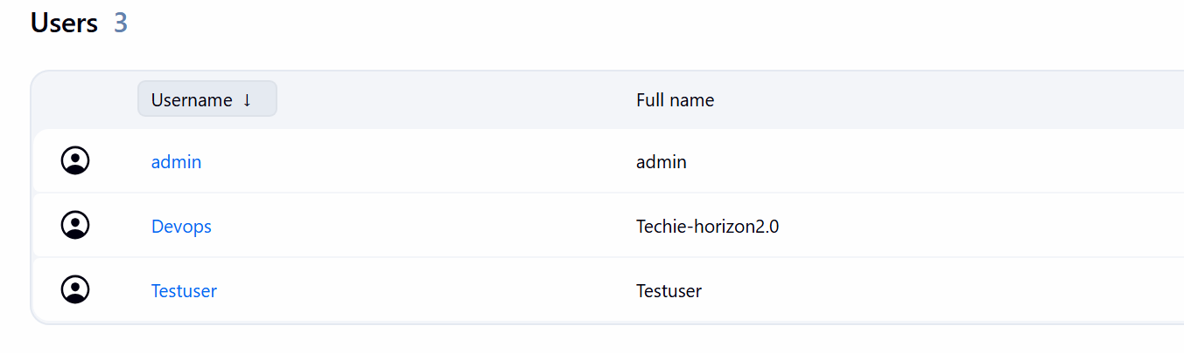

— Give Limited Permissions
Now we will restrict these users.
Go to:
Manage Jenkins → Security
Under:
Authorization → Matrix-based security
You'll see something similar to:
User/Group Overall Job Run View
------------------------------------------------
jenkinsadmin
DevOps
Testing
DevOps Permissions
Give DevOps only the permissions needed to view and execute jobs.
A reasonable lab configuration:
DevOps
Overall: ☑ Read
Job: ☑ Read ☑ Build ☑ Cancel
View: ☑ Read

Testing Permissions
For Testing: Testing
Overall: ☑ Read
Job: ☑ Read ☑ Build ☑ Cancel
View: ☑ Read
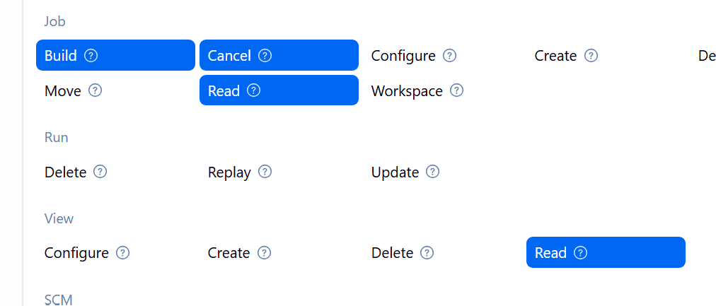
Do not give administrative permissions.
4. Configure labels and restrict the jobs to execute based on label only.
Configure Labels
Go to: Manage Jenkins → Nodes → Built-In Node → Configure
Set:
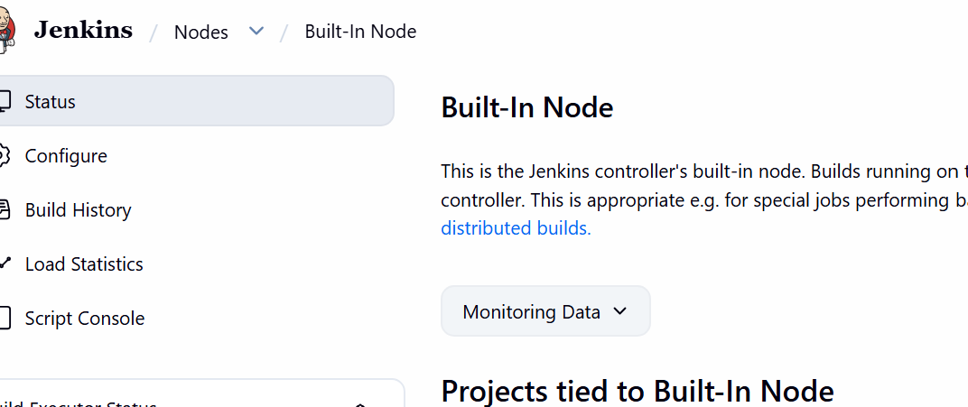
Labels: linux
Save.
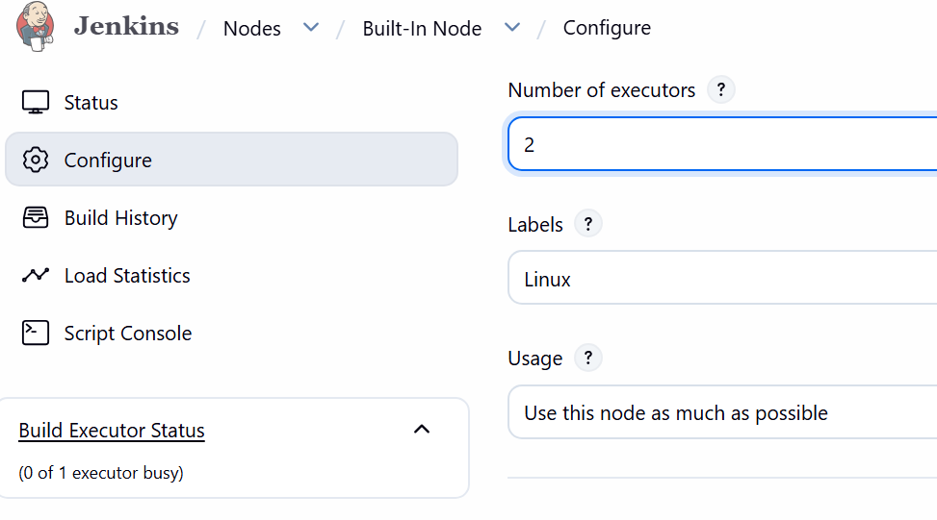
If you have another agent:
Labels: docker
Then jobs can be restricted to a specific node.
5.Create Three sample jobs using the below URL.
• Source Code: https://github.com/betawins/Techie_horizon_Login_app.git
Use the same GitHub source for all three jobs:
Techie-Horizon-Git-Checkout
Job 1: Login-App-Checkout1
New Item → Freestyle Project
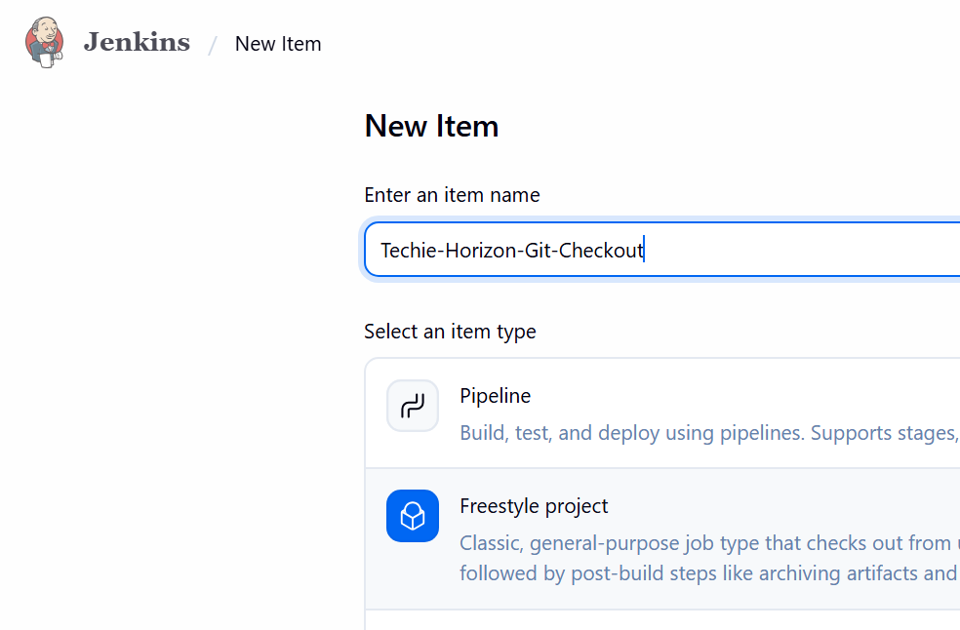
• Source Code Management → Git
• Repository URL → above URL
• Restrict where → linux
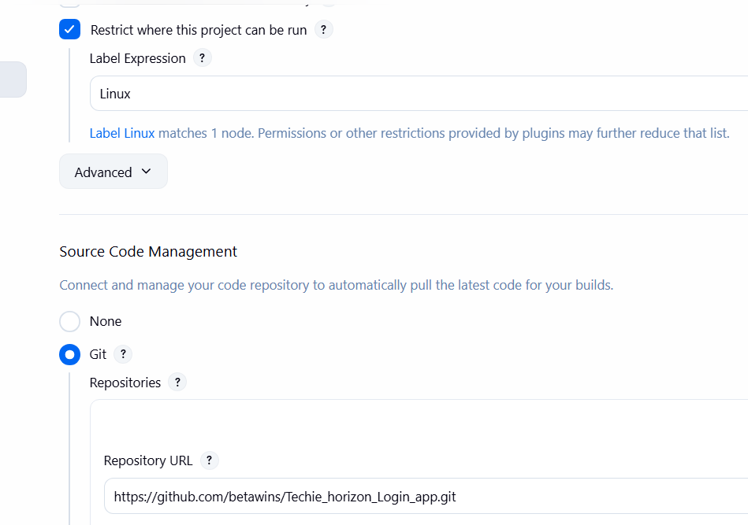
• Build → Execute Shell:
echo "======================================"
echo "Private Repository Build"
echo "======================================"
echo "Current user:"
whoami
echo "Workspace:"
pwd
echo "Repository files:"
ls -la
echo "Git information:"
git log -1 --oneline
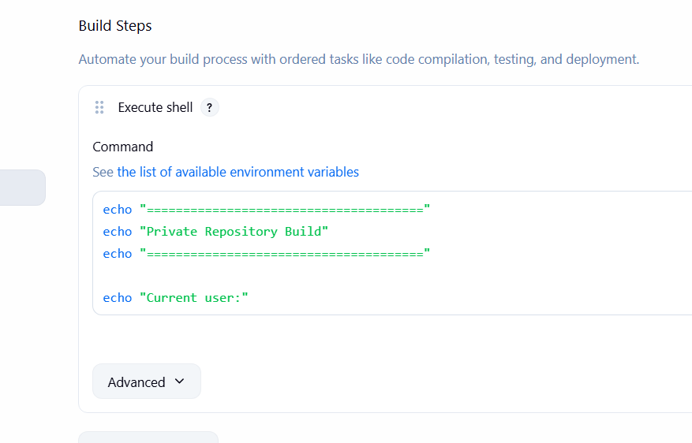
• Save → Build Now
Job 2: Techie-Horizon-App-Build
• Create Freestyle Project
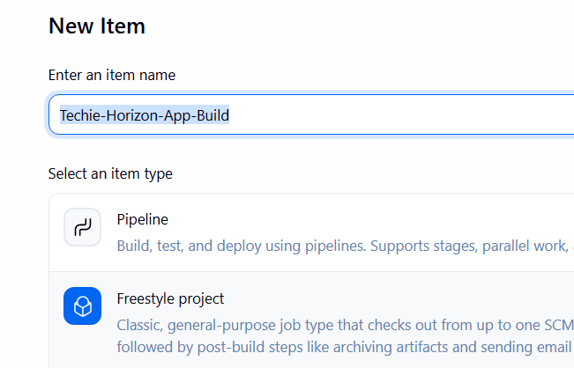
• Git → same repository URL
• Label → linux
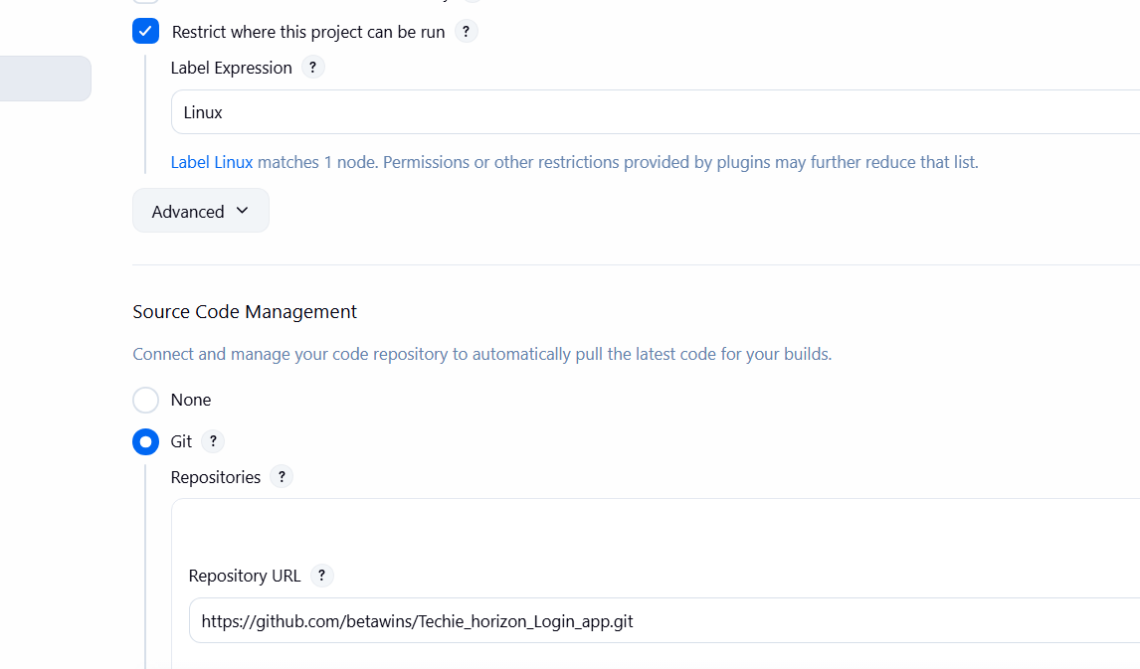
• Build command: echo "Building application"
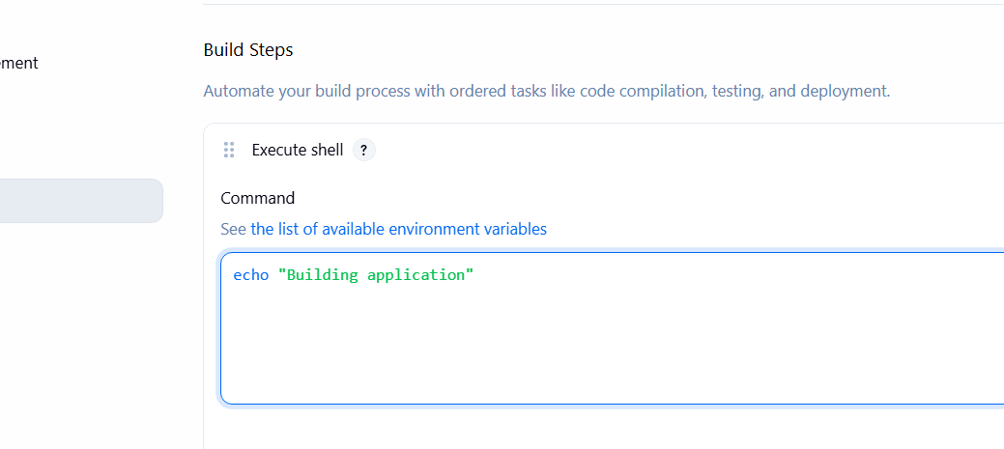
• Save → Build Now
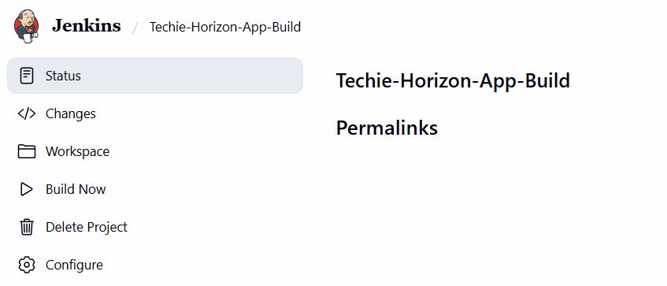
Job 3: Techie-Login-App-Test
• Create Freestyle Project
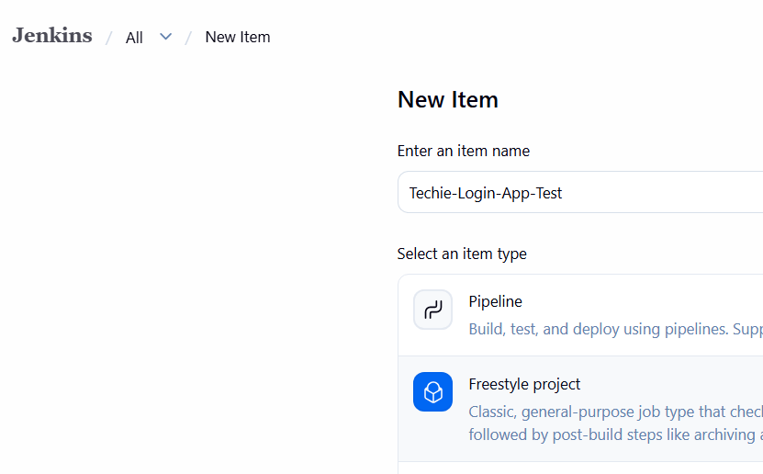
• Git → same repository URL
• Label → linux
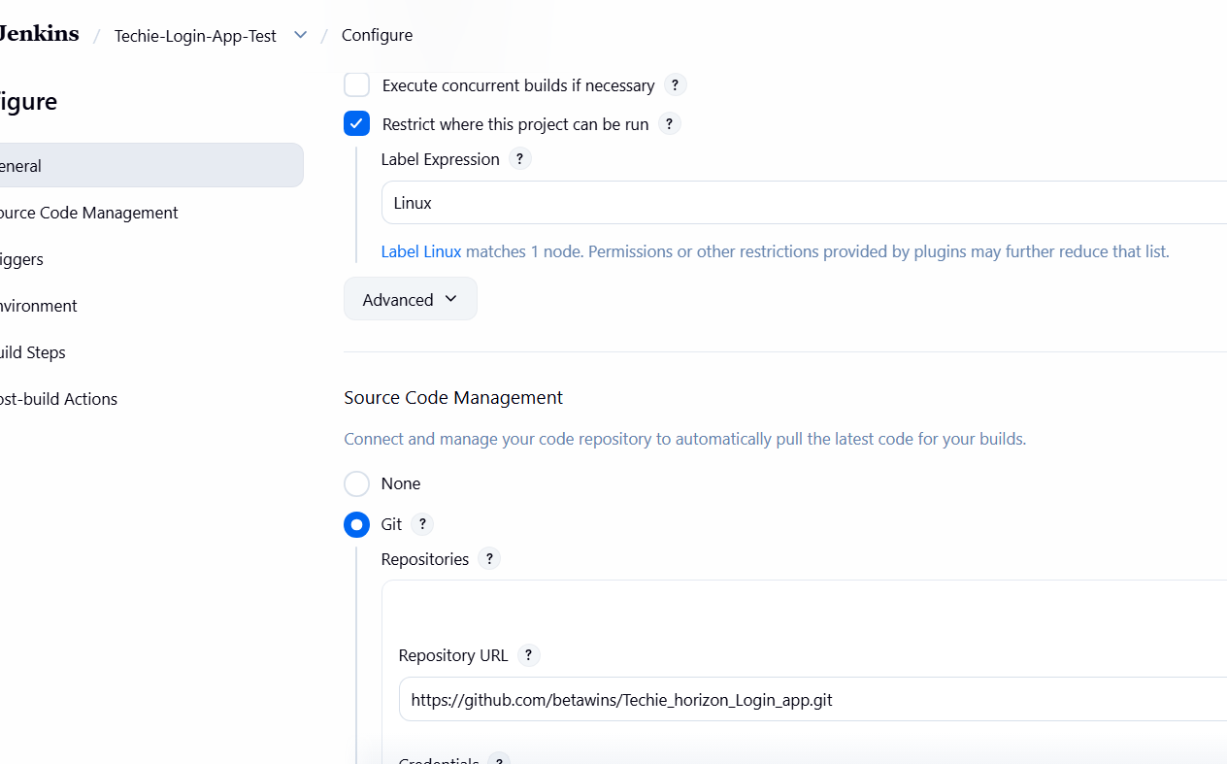
• Build command: echo "Testing application"
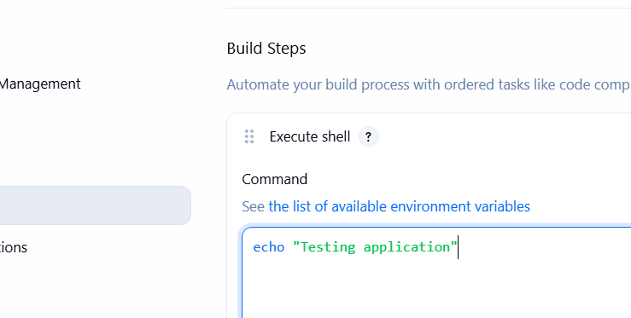
• Save → Build Now
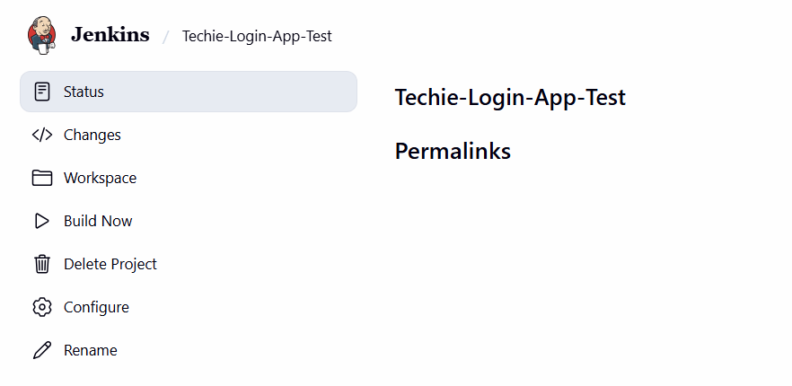Result: 3 jobs will checkout the same source code and execute only on the linux labeled node.
6. Create one Jenkins job using GitHub Private repository.
Jenkins Job Using GitHub Private Repository -> jenkins-private-demo
GitHub: Create a Private Repository and add your source code. 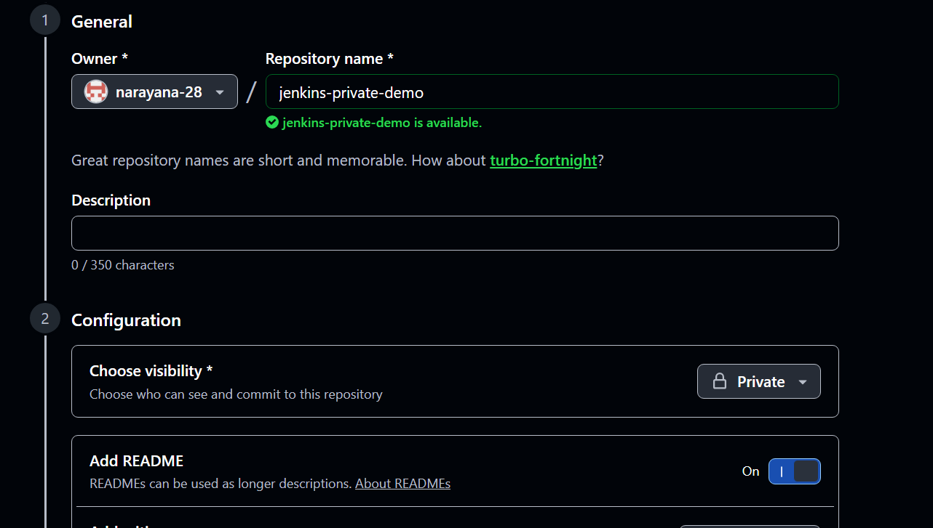
1. Create GitHub PAT:
GitHub → Settings → Developer settings → Personal access tokens → Generate
token.
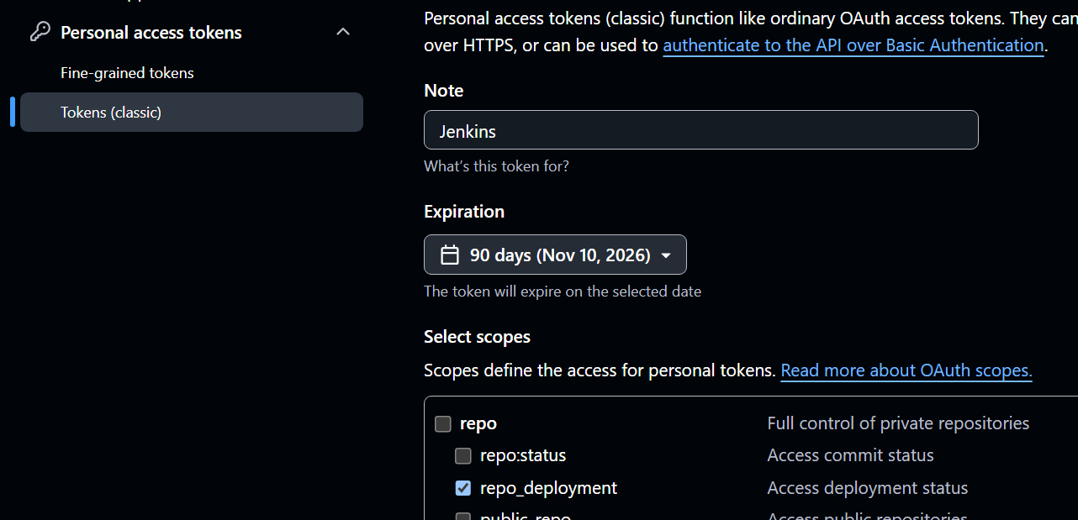
2. Add credentials in Jenkins:
Manage Jenkins → Credentials → System → Global credentials → Add Credentials

o Kind: Username with password
o Username: GitHub username
o Password: GitHub PAT
o ID: github-private
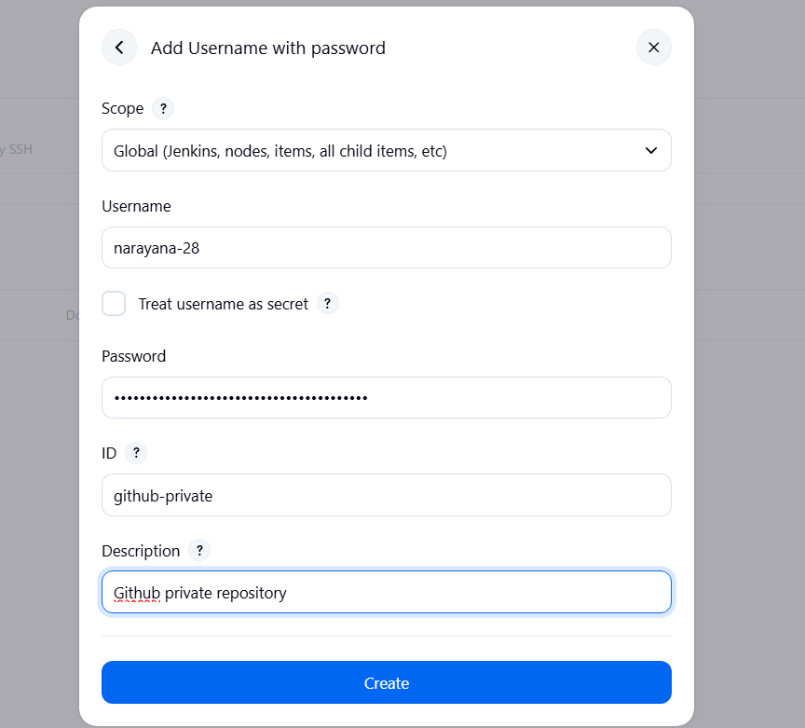
3. Create Job:
New Item → Private-GitHub-Job → Freestyle Project
4. Configure Git:
o Source Code Management → Git
o Repository URL:
https://github.com/<username>/<private-repo>.git
Credentials: github-private
5. Restrict to label: linux
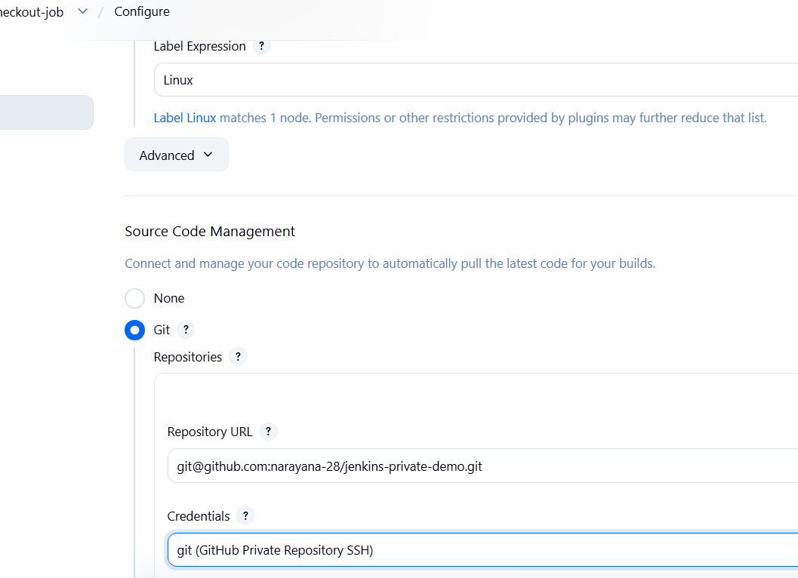
6. Build → Execute Shell: echo "Private repository checkout successful"
ls -la
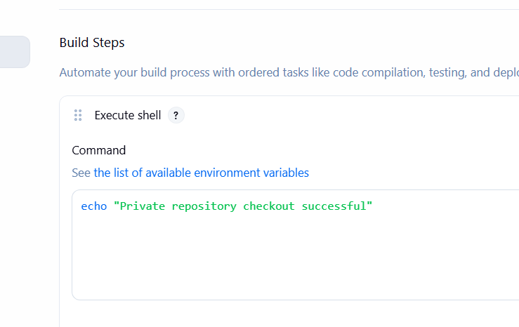
7. Save → Build Now
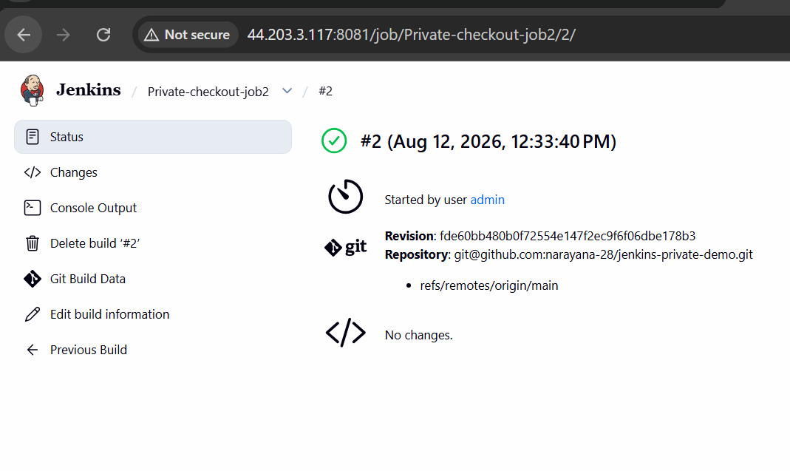
Here I faced error because the private repository which I have create using main branch but in the job I have used master here we have to change master to main if we use master the job may fail
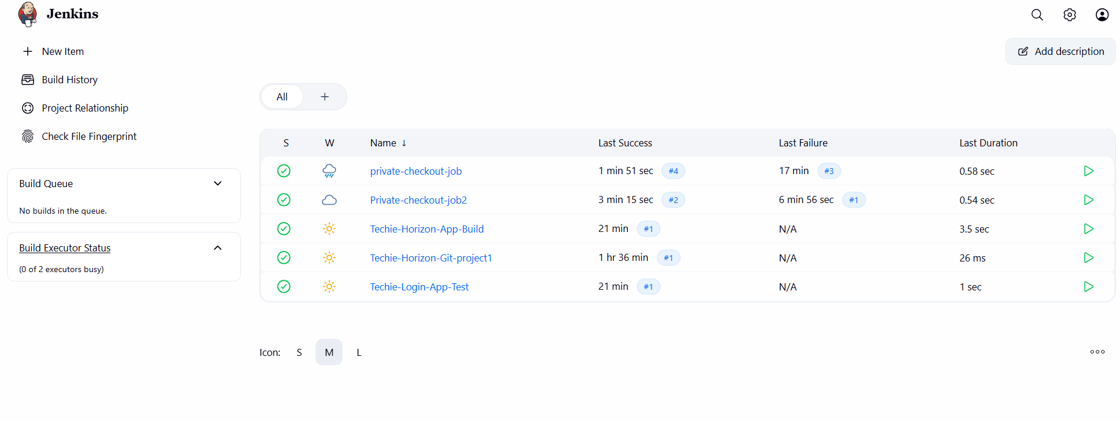
Successful, Jenkins has successfully accessed the private GitHub repository.

